1. 34.7 mL of 1.80 M nitric acid is added to 20.7 mL of calcium hydroxide, and the resulting solution is found to be acidic.
18.5 mL of 2.38 M sodium hydroxide is required to reach neutrality.
What is the molarity of the original calcium hydroxide solution?
 M
2. Potassium hydrogen phthalate is a solid, monoprotic acid frequently used in the laboratory to standardize strong base solutions. It has the unwieldy formula of KHC₈H₄O₄. This is often written in shorthand notation as KHP.
How many grams of KHP are needed to exactly neutralize 23.2 mL of a 0.435 M barium hydroxide solution ?
 grams KHC₈H₄O₄
3.A 14.0 g sample of an aqueous solution of hydrobromic acid contains an unknown amount of the acid.
If 29.8 mL of 0.611 M potassium hydroxide are required to neutralize the hydrobromic acid, what is the percent by mass of hydrobromic acid in the mixture?
 % by mass
4.
A 13.1 g sample of an aqueous solution of nitric acid contains an unknown amount of the acid.
If 22.8 mL of 0.456 M potassium hydroxide are required to neutralize the nitric acid, what is the percent by mass of nitric acid in the mixture?
 % by mass
5.
In the laboratory a student combines 49.7 mL of a 0.368 M barium iodide solution with 27.5 mL of a 0.612 M magnesium iodide solution.
What is the final concentration of iodide anion ?
 M
6. In the laboratory a student combines 39.3 mL of a 0.165 M manganese(II) chloride solution with 25.3 mL of a 0.328 M manganese(II) sulfate solution.
What is the final concentration of manganese(II) cation ?
 M
7. In the laboratory you dissolve 16.6 g of manganese(II) chloride in a volumetric flask and add water to a total volume of 250 mL.
What is the molarity of the solution? 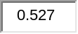 M.
What is the concentration of the manganese(II) cation? M.
What is the concentration of the chloride anion?  M.
8. In the laboratory you dissolve 14.1 g of barium iodide in a volumetric flask and add water to a total volume of 375 mL.
What is the molarity of the solution? 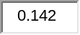 M.
What is the concentration of the barium cation? M.
What is the concentration of the iodide anion? 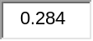 M.
9.
Write a net ionic equation for the reaction that occurs when aqueous solutions of perchloric acid and ammonia are combined. Are they aq, liquid, gas, or solid?
 | + | 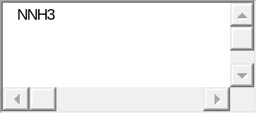 |  | 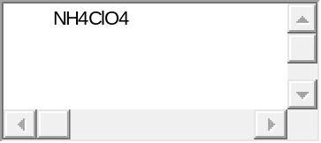 | + | 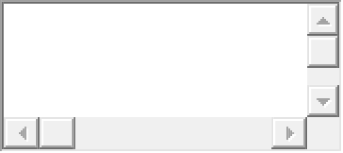

10. Write a net ionic equation for the reaction that occurs when aqueous solutions of hypochlorous acid and ammonia are combined.
are they liquid, gas, solid, or aq?
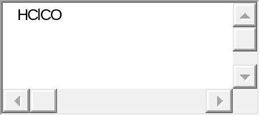 | + | 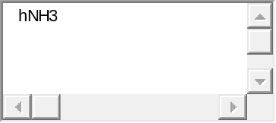 |  | 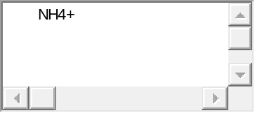 | + | 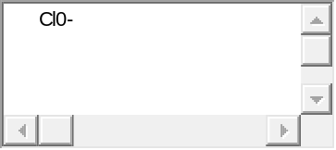

11. Write a net ionic equation for the reaction that occurs when aqueous solutions of barium hydroxide and nitric acid are combined.
BaOH +
are they liquid, solid, gas, or aq?

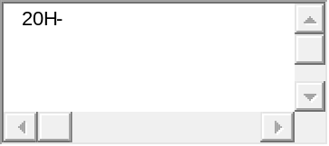 | + | 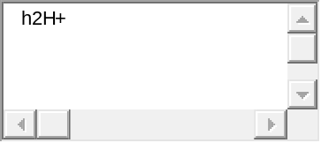 |  | 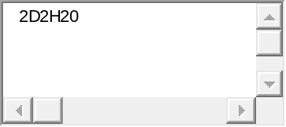 | +
12. Write a net ionic equation for the reaction that occurs when aqueous solutions of hydrocyanic acid and sodium hydroxide are combined. Are they liquid, solid, gas, or aq?

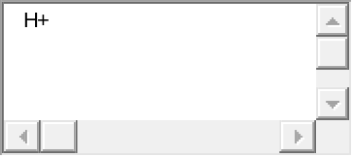 | + | 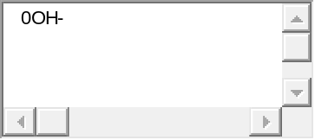 |  | 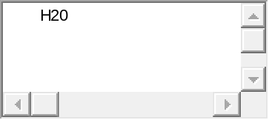 | +

13. An aqueous solution of barium hydroxide is standardized by titration with a 0.199 M solution of hydrobromic acid.
If 23.4 mL of base are required to neutralize 25.6 mL of the acid, what is the molarity of the barium hydroxide solution?
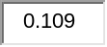M barium hydroxide
14. An aqueous solution of nitric acid is standardized by titration with a 0.164 M solution of barium hydroxide.
If 13.3 mL of base are required to neutralize 11.4 mL of the acid, what is the molarity of the nitric acid solution?
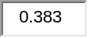M nitric acid
15. What volume of a 0.199 M barium hydroxide solution is required to neutralize 23.4 mL of a 0.334 M hydrobromic acid solution?
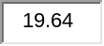mL barium hydroxide
16. What volume of a 0.121 M nitric acid solution is required to neutralize 13.3 mL of a 0.164 M calcium hydroxide solution?
 mL nitric acid
17. How many mL of 0.657 M HBr are needed to dissolve 5.35 g of CaCO₃?
2HBr(aq) + CaCO₃(s) CaBr₂(aq) + H₂O(l) + CO₂(g)
 mL

18. How many mL of 0.657 M HBr are needed to dissolve 5.35 g of CaCO₃?
2HBr(aq) + CaCO₃(s) CaBr₂(aq) + H₂O(l) + CO₂(g)
mL
19. A student determines the copper(II) content of a solution by first precipitating it as copper(II) hydroxide, and then decomposing the hydroxide to copper(II) oxide by heating. How many grams of copper(II) oxide should the student obtain if her solution contains 32.0 mL of 0.433 M copper(II) nitrate?
 g
20. A 0.5342 g sample of a pure soluble bromide compound is dissolved in water, and all of the bromide ion is precipitated as AgBr by the addition of an excess of silver nitrate. The mass of the resulting AgBr is found to be 0.9304 g.
What is the mass percentage of bromine in the original compound? 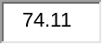 %

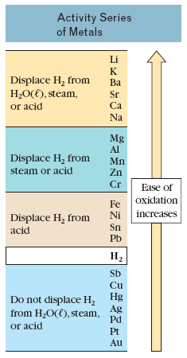

21.
Use the table on the information page to predict if a reaction will occur when manganese metal and zinc bromide(aq) are combined. If a reaction occurs, write a balanced equation for the reaction. Are they aq, liquid, solid, or gas
A reaction will occur since Manganese is above Zinc in the reactivity Series
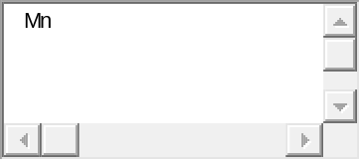 | + | 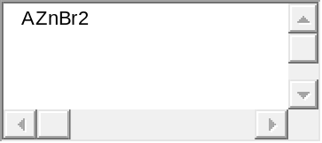 |  | 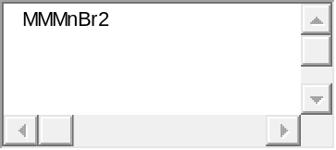 | + | 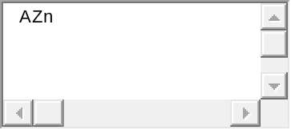

22.
Use the pull-down boxes to specify states such as (aq) or (s).
If a box is not needed leave it blank.
If no reaction occurs leave all boxes blank and click on "submit".
Use the table on the information page to predict if a reaction will occur when manganese metal and zinc bromide(aq) are combined. If a reaction occurs, write a balanced equation for the reaction. Are they aq, solid, gas, or liquid.
 | + |  |  | 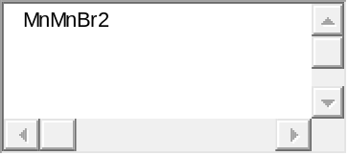 | + | 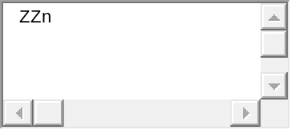

Assigning Oxidation Numbers
Use these rules in order.
The sum of all oxidation numbers of all elements = charge on substance.
 |  | Oxidation Number: | Examples:
1. | Atoms in their elemental state | 0 | Fe, H₂, O₂
2. | Monatomic ions | = charge | F⁻, Fe³⁺
IN COMPOUNDS
3. | Group 1A | +1 | NaCl, KNO₃
4. | Group 2A | +2 | MgO
5. | Fluorine | −1 | HF, ClF
6. | Hydrogen | +1 | H₂O
7. | Oxygen | −2 | SO₂, HClO₄
8. | Group 7A | −1 | HCl
9. | Group 6A

23.
2Cr + 3Cl₂+ 6OH⁻6Cl⁻ + 2Cr(OH)₃
In the above redox reaction, use oxidation numbers to identify the element oxidized, the element reduced, the oxidizing agent and the reducing agent.

name of the element oxidized: |  |  | name of the element reduced: | 
formula of the oxidizing agent: | 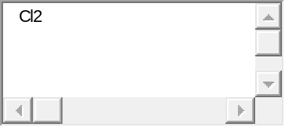 |  | formula of the reducing agent: | 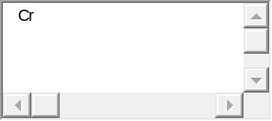

24. Use the References to access important values if needed for this question.

HNO₂ + SO₄²⁻+ H⁺ H₂SO₃ + NO₃⁻

In the above redox reaction, use oxidation numbers to identify the element oxidized, the element reduced, the oxidizing agent and the reducing agent.

name of the element oxidized: |  |  | name of the element reduced: | 
formula of the oxidizing agent: | 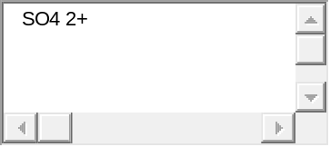 |  | formula of the reducing agent: | 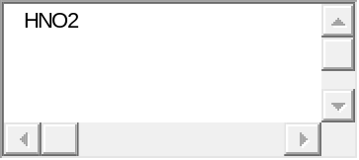

25.
Identify the species oxidized, the species reduced, the oxidizing agent and the reducing agent in the following electron transfer reaction.
3Sn²⁺ + 2Al3Sn + 2Al³⁺
species oxidized |  | species reduced
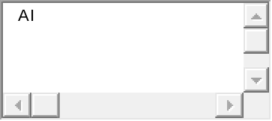 |  | 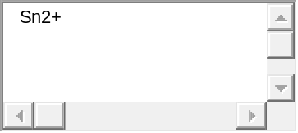
oxidizing agent |  | reducing agent
 |  | 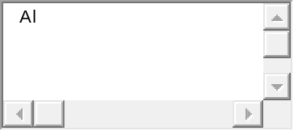

As the reaction proceeds, electrons are transferred from |  | to |  | .

26. Identify the species oxidized, the species reduced, the oxidizing agent and the reducing agent in the following electron transfer reaction.
2Fe³⁺ + Mg2Fe²⁺ + Mg²⁺
species oxidized |  | species reduced
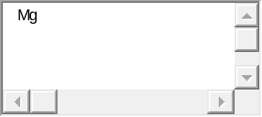 |  | 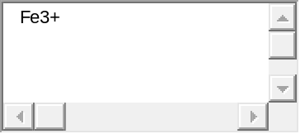
oxidizing agent |  | reducing agent

As the reaction proceeds, electrons are transferred from |  | to |  | .

Solubility Rules for some ionic compounds in water
Soluble Ionic Compounds
1. | All sodium (Na⁺), potassium (K⁺), and ammonium (NH₄⁺) salts are SOLUBLE.
2. | All nitrate (NO₃⁻), acetate (CH₃CO₂⁻), chlorate (ClO₃⁻ ), and perchlorate (ClO₄⁻) salts are SOLUBLE.
3. | All chloride (Cl⁻), bromide (Br⁻), and iodide (I⁻) salts are SOLUBLE -- EXCEPT those also containing: lead, silver, or mercury (I) (Pb²⁺,Ag⁺, Hg₂²⁺) which are NOT soluble.
4. | All sulfate (SO₄²⁻) salts are SOLUBLE - - EXCEPT those also containing: calcium, silver, mercury (I), strontium, barium, or lead (Ca²⁺, Ag⁺, Hg₂²⁺, Sr²⁺, Ba²⁺, Pb²⁺) which are NOT soluble.
Not Soluble Ionic Compounds
5. | Hydroxide (OH⁻) and oxide (O²⁻) compounds are NOT SOLUBLE -- EXCEPT those also containing: sodium, potassium, or barium (Na⁺, K⁺, Ba²⁺) which are soluble.
6. | Sulfide (S²⁻) salts are NOT SOLUBLE -- EXCEPT those also containing: sodium, potassium, ammonium, or barium (Na⁺, K⁺, NH₄⁺, Ba²⁺) which are soluble.
7. | Carbonate (CO₃²⁻) and phosphate (PO₄³⁻) salts are NOT SOLUBLE -- EXCEPT those also containing: sodium, potassium, or ammonium (Na⁺, K⁺, NH₄⁺) which are soluble.
Soluble compounds are defined as those that dissolve to the extent of 1 g or more per 100 g water.
NOT soluble compounds are further classified as:
-Slightly soluble, which dissolve to the extent of 0.01 g to 1 g per 100 g water.
-Difficul
Writing Net Ionic Equations
1. Write reactants.
2. Write products by exchanging cations.
3. Dissociate (write as ions) ALL soluble salts, strong acids, and strong bases (except Ca(OH)₂).
Reminder: Do not break up polyatomic ions i.e., K₂SO₄ → 2 K⁺ + SO₄²⁻ NOT S²⁻ + 4 O²⁻
4. Balance.
5. Cross out identical (spectator) ions on both sides of the equation.
6. Rewrite NET IONIC EQUATION. CHECK atom and charge balance.

Strong Acids | Strong Bases
HCl, HBr, HI | NaOH
HNO₃ | KOH
HClO₄ | Ca(OH)₂ slightly soluble
H₂SO₄ | Ba(OH)₂
tly soluble or Insoluble, for which less than 0.01 g per 100 g water will dissolve.

27. Consider the reaction when aqueous solutions of iron(II) sulfate and barium sulfide are combined.
(Use the solubility rules provided in the OWL Preparation Page to determine the solubility of compounds.)
The net ionic equation for this reaction is: are they aq, solid, gas, or liquid/
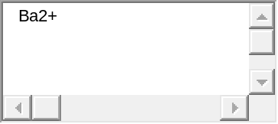 | + | 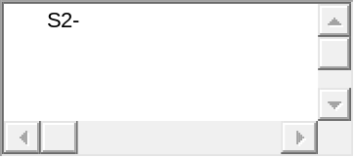 | + | 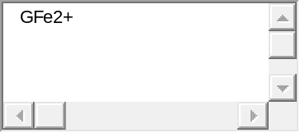 | + | 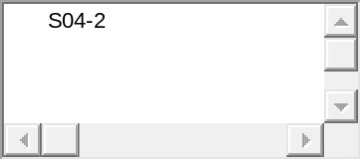

 | 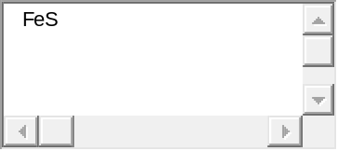 | + | 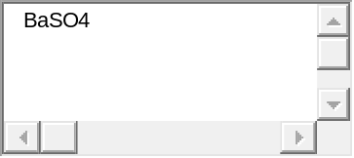

28.
Use the pull-down boxes to specify states such as (aq) or (s).
If a box is not needed leave it blank.
If no reaction occurs leave all boxes blank and click on "Submit".
Consider the reaction when aqueous solutions of potassium nitrate and barium hydroxide are combined.
(Use the solubility rules provided in the OWL Preparation Page to determine the solubility of compounds.)
The net ionic equation for this reaction is:
 |  | + |  |  |  | + |  | 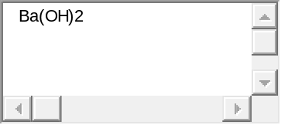 |  | +
 |  |  | + |  |  |  | + |  |  |  | +

29.
Consider the reaction when aqueous solutions of aluminum bromide and potassium hydroxide are combined.
(Use the solubility rules provided in the OWL Preparation Page to determine the solubility of compounds.)
The net ionic equation for this reaction is:
is it aq, solid, liquid, or gas.
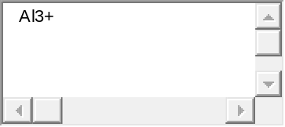 | + | 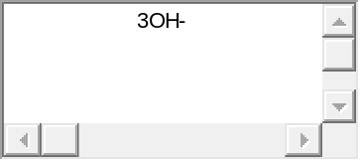 | + | 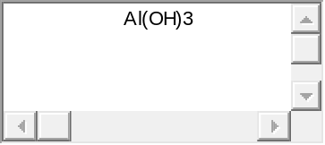 | + |  |  |  | +
30.
Consider the reaction when aqueous solutions of nickel(II) sulfate and chromium(III) nitrate are combined.
(Use the solubility rules provided in the OWL Preparation Page to determine the solubility of compounds.)
The net ionic equation for this reaction is:
          

